# 3. Install Micro:bit Driver：

Link Micro:bit board with computer by micro USB cable，then open the link：https://fs.keyestudio.com/KS0361-0365 to download the driver of Micro:bit main board.

Double-click 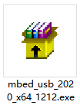 after downloading the driver.

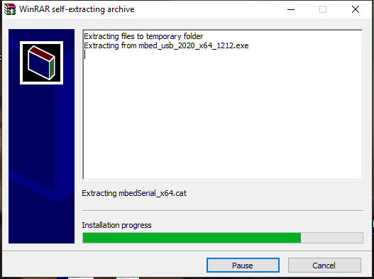

Then click“Next”

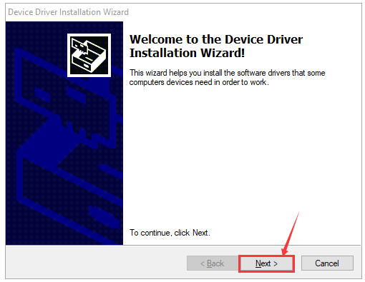\

The following page pops up and click“install”

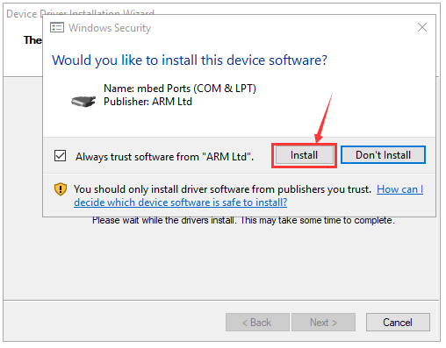

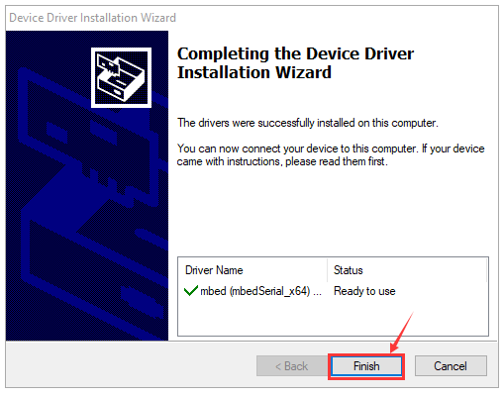

Click“Finish”. Then click“Computer” —>“Properties”—> “Device manager”, as shown below.

